Free Education on Environmentally Sustainable Practices
This month, the WMA’s My Green Doctor program is the focus of a free 40-minute online program offered by the American Medical Association to any physician in the world, not just AMA members. Watch the webinar yourself at any time and ask your clinic manager to watch as well to learn how easy it is to save money with environmentally sustainable practice management. There is one link to watch the webinar and another to claim education credit: https://event.on24.com/wcc/r/4062883/B0A8A10449AF6354586D76FEE9D19978
Education credit: https://edhub.ama-assn.org/steps-forward/module/2800484

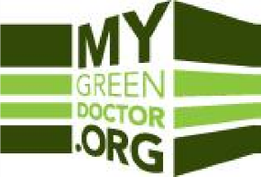
My Green Doctor is a free money-saving membership & climate-saving benefit from the World Medical Association. Medical offices use My Green Doctor’s “Meeting-by-Meeting Guide” to learn how to adopt environmental sustainability, save resources, and help create healthier communities. The program adds just five minutes to each regular office staff meeting or weekly office “huddle”, making small changes at each meeting that over time really add up.

Everyone in your practice can register as Partner Society members at www.MyGreenDoctor.org or at www.MyGreenDoctor.es (si, en Espanol) and can use the discount code MGDWMA to save $60 instantly and give full access forever to My Green Doctor for free. Ask your clinic or practice manager to register today and to put My Green Doctor on your next agenda. You can do this!

