Curriculum Vitae

Marit Hermansen | 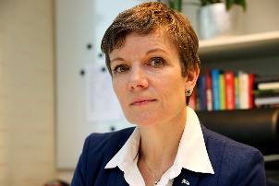
Born 1964

Education:
1992 MD, University of Bergen
2003 Specialist General Practice

Professional Experience:
1992-1993 Medical Intern, Kongsvinger Hospital
1994 Medical Intern, Leksvik Municipality
1995 Resident Doctor Paediatric psychiatry department Haukeland hospital
1995-1996 Resident Medical department, Kongsvinger hospital
1996- 2016 General Practitioner, Grue Municipality
1998- 2015 Public Health officer 40 %, Grue municipality
2009-2014 Head of out of hours medical emergency services, Solør
From 1.9.11 On leave due to professional representative functions

Representative functions in the Norwegian Medical Association
1995 local representative for the resident doctors at the paediatric psychiatry department Haukeland hospital
2003-2005 Norwegian Association of General Practitioners (NSAM) alternate member of the board
2005-2007 NSAM, vice chair
2007-2009 Norwegian Association for General Medicine (NFA), member of the board
2009-2011 Fund for quality and patient safety alternate member of the steering committee
2011- 2014 Fund for quality and patient safety member of the steering committee
2011- NFA, leader
2012-2015 Research fund for General medicine, chair
2013-2015 Board of the Norwegian Medical Association, member
2014- Centre for quality at physicians' practices (SKIL) chair
2015-2021 Chair of council (President) of the Norwegian Medical Association

International representative functions
2011 – 2015 Member of WONCA Europe Council
2013 WONCA world council
2019- Member of Council World Medical Association

Other representative functions
2007-2010 National Centre for Rural medicine (NSDM) alternate representative to the steering group
2014-2015 National Centre for emergency out of hours medicine (NKLM) member of the reference group
2014 Centre for antibiotics for primary health care (ASP) member of the reference group
2015-2016 Acting chair of council for The Federation of Norwegian Professional Associations (Akademikerne)

